|  |  |  |  |
| --- | --- | --- | --- |
| |  |  | | --- | --- | |  | CCS3351 Mobile Application Development  Mid term project (100 marks) | |  |

### Instructions:

* Submit your answers as a single file (**.ZIP**) on or before the deadline provided in the LMS.
* Submission must include this document explaining your code, UI and lessons learnt
* Late submission will not be considered for the marking.
* Make sure to include this document in your submission

|  |  |
| --- | --- |
| Full name: |  |
| Student index: |  |
| Date of submission: |  |

# Understanding layout

The core of Flutter’s layout mechanism is widgets. In Flutter, almost everything is a widget—even layout models are widgets. The images, icons, and text that you see in a Flutter app are all widgets. But things you don’t see are also widgets, such as the rows, columns, and grids that arrange, constrain, and align the visible widgets. You create a layout by composing widgets to build more complex widgets.

Here’s an example of a book store app, showing a list of books. Observe the completed UI (browser and emulator) and understand the breakdown. Create the Book layout as a custom widget, which can be reused.

## Single book

|  |  |
| --- | --- |
| Browser |  |

**Widget layout**

You may or may not use a Card to enclose the elements. The layout uses 4 elements inside a Column and 2 elements in the last Row. Text widget is used for Title, Author and Price.

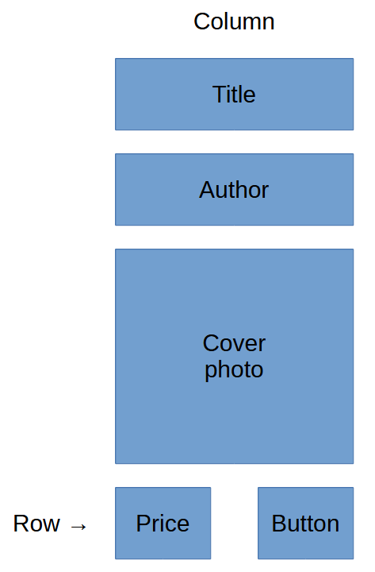

## Exercise: Basic Flutter UI (total marks: 100)

1. Draw the widget hierarchy diagram (20 marks)
2. Create the widget as per the UIs given (20 marks)
3. Create 3 child elements (objects) from the widget you created (20 marks)
4. Copy paste the code to your document (10 marks) or include a repo link
5. Copy paste the UI to your document (10 marks)
6. Write a note on lessons learned and your rationale for selecting components from the library (20 marks)
7. ZIP the whole project folder along with this document and upload to LMS

Sample code with a list of 3 books

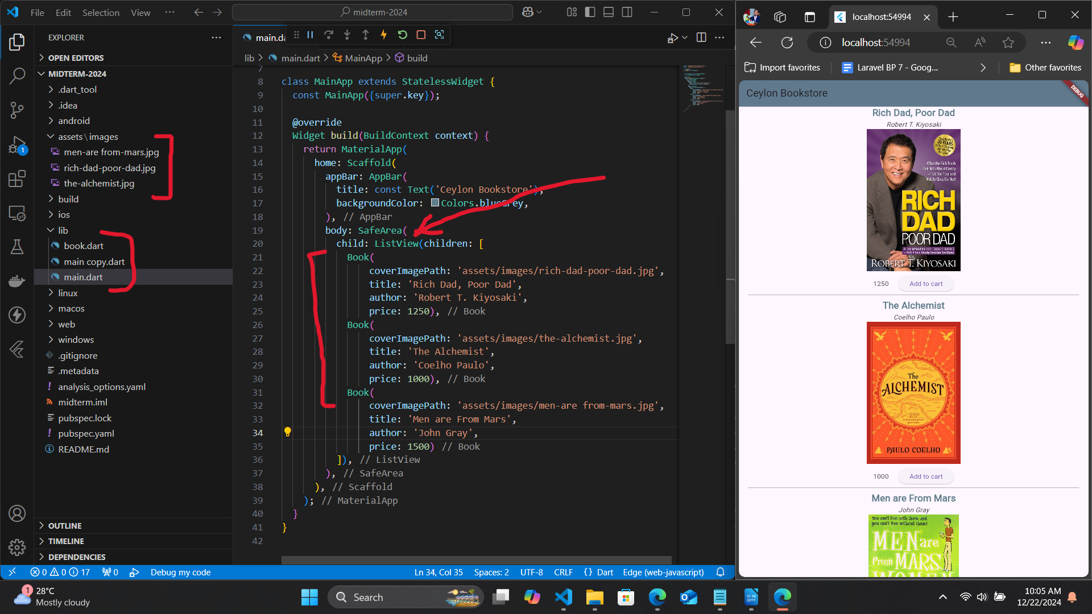

Read the documentation here:

* https://docs.flutter.dev/ui/layout
* https://docs.flutter.dev/ui/layout/tutorial
* https://medium.com/flutter-community/flutter-layout-cheat-sheet-5363348d037e
* https://www.flutterbeads.com/set-background-image-in-flutter/
* https://www.flutterbeads.com/flutter-position-widget-in-stack/

# Code

import 'package:flutter/material.dart';

import 'package:flutter_example/Flutter%20UI/Book%20%20App%20UI/models/book.dart';

import 'package:flutter_rating/flutter_rating.dart';

bool isCart = true;

bool isFavorite = true;

class BookDetailScreen extends StatefulWidget {

  final Book book;

  const BookDetailScreen({super.key, required this.book});

  @override

  State<BookDetailScreen> createState() => _BookDetailScreenState();

}

class _BookDetailScreenState extends State<BookDetailScreen> {

  String cartText = "Add to cart";

  @override

  void initState() {

    isCart = false;

    isFavorite = false;

    super.initState();

  }

  @override

  Widget build(BuildContext context) {

    return Scaffold(

      backgroundColor: Colors.white,

      appBar: headerParts(context),

      body: ListView(

        children: [

          Column(

            children: [

              Padding(

                padding: const EdgeInsets.symmetric(horizontal: 15),

                child: Row(

                  mainAxisAlignment: MainAxisAlignment.center,

                  crossAxisAlignment: CrossAxisAlignment.center,

                  children: [

                    Hero(

                      tag: widget.book.cover,

                      child: Image.network(

                        widget.book.cover,

                        fit: BoxFit.fill,

                        height: 260,

                        width: MediaQuery.of(context).size.width / 2.5,

                      ),

                    ),

                    const SizedBox(width: 10),

                    Column(

                      crossAxisAlignment: CrossAxisAlignment.start,

                      children: [

                        SizedBox(

                          width: MediaQuery.of(context).size.width / 2,

                          child: Text(

                            widget.book.title,

                            style: const TextStyle(

                              fontSize: 25,

                              fontWeight: FontWeight.w700,

                              color: Colors.black54,

                            ),

                            softWrap: true,

                          ),

                        ),

                        const SizedBox(height: 15),

                        Row(

                          children: [

                            CircleAvatar(

                              radius: 35,

                              backgroundImage: NetworkImage(

                                widget.book.authorImg,

                              ),

                            ),

                            const SizedBox(width: 5),

                            Text(

                              widget.book.author,

                              maxLines: 1,

                              style: const TextStyle(

                                fontSize: 18,

                                fontWeight: FontWeight.w500,

                              ),

                            )

                          ],

                        ),

                        const SizedBox(height: 10),

                        Row(

                          children: [

                            StarRating(

                              rating: widget.book.rating,

                              size: 20,

                              color: Colors.amber,

                            ),

                            const SizedBox(width: 5),

                            Text(

                              widget.book.rating.toString(),

                              style: const TextStyle(

                                color: Colors.black38,

                                fontSize: 15,

                              ),

                            )

                          ],

                        )

                      ],

                    )

                  ],

                ),

              ),

              Padding(

                padding: const EdgeInsets.only(top: 30),

                child: Container(

                  height: 110,

                  padding:

                      const EdgeInsets.only(left: 20, right: 20, bottom: 20),

                  child: ListView(

                    scrollDirection: Axis.horizontal,

                    children: [

                      moviMoreInfo(

                        "https://cdn.vectorstock.com/i/thumb-large/93/62/psychology-icon-vector-15909362.jpg",

                        widget.book.genre,

                        "Genera",

                      ),

                      const SizedBox(width: 10),

                      moviMoreInfo(

                        "https://cdn2.iconfinder.com/data/icons/translation-1/513/translation-translate-language-international-translating_2_copy_7-512.png",

                        widget.book.lanugage,

                        "Language",

                      ),

                      const SizedBox(width: 10),

                      moviMoreInfo(

                        "https://cdn-icons-png.flaticon.com/512/4994/4994482.png",

                        widget.book.age,

                        "Age",

                      )

                    ],

                  ),

                ),

              ),

              infoAndReview()

            ],

          ),

        ],

      ),

      floatingActionButton: FloatingActionButton.extended(

        backgroundColor: Colors.white,

        onPressed: () {},

        label: Row(

          children: [

            RichText(

              text: TextSpan(

                children: [

                  TextSpan(

                    text: "\$${widget.book.price}",

                    style: const TextStyle(

                      color: Colors.black,

                      fontSize: 30,

                      fontWeight: FontWeight.w500,

                    ),

                  ),

                  TextSpan(

                    text: "\$${widget.book.price + 4.5}",

                    style: const TextStyle(

                        color: Colors.black38,

                        fontSize: 15,

                        decoration: TextDecoration.lineThrough),

                  ),

                ],

              ),

            ),

            const SizedBox(width: 20),

            ElevatedButton(

              style: ElevatedButton.styleFrom(

                padding:

                    const EdgeInsets.symmetric(horizontal: 22, vertical: 10),

                backgroundColor: isCart ? Colors.red : Colors.black54,

              ),

              onPressed: () {

                setState(() {

                  isCart = !isCart;

                  cartText =

                      (isCart == false) ? "Add to cart" : "Remove from cart";

                });

              },

              child: Row(

                children: [

                  const Icon(

                    Icons.shopping_cart,

                    color: Colors.white,

                  ),

                  const SizedBox(width: 5),

                  Text(

                    cartText,

                    style: const TextStyle(

                      fontWeight: FontWeight.bold,

                      color: Colors.white,

                    ),

                  )

                ],

              ),

            ),

          ],

        ),

      ),

    );

  }

  SizedBox infoAndReview() {

    return SizedBox(

      height: 400,

      width: double.infinity,

      child: DefaultTabController(

        length: 2,

        child: Scaffold(

          backgroundColor: Colors.transparent,

          appBar: PreferredSize(

            preferredSize: const Size.fromHeight(50),

            child: SafeArea(

              child: Column(

                children: [

                  Expanded(

                    child: Container(),

                  ),

                  const TabBar(

                    labelPadding: EdgeInsets.only(

                      bottom: 13,

                    ),

                    indicatorColor: Colors.black,

                    unselectedLabelColor: Colors.black38,

                    tabs: [

                      Text("Info"),

                      Text("Reviews"),

                    ],

                  ),

                ],

              ),

            ),

          ),

          body: TabBarView(

            children: [

              Padding(

                padding: const EdgeInsets.all(20),

                child: ListView(

                  children: [

                    const Text(

                      "Summary",

                      style: TextStyle(

                        fontSize: 28,

                        fontWeight: FontWeight.w700,

                        letterSpacing: 1.3,

                        height: 2,

                      ),

                    ),

                    Text(

                      widget.book.summary,

                      style: const TextStyle(fontSize: 17),

                      softWrap: true,

                    ),

                  ],

                ),

              ),

              const Center(

                child: Text(

                  "No Reviews Available",

                  style: TextStyle(

                    fontWeight: FontWeight.w700,

                    fontSize: 25,

                    color: Colors.black54,

                  ),

                ),

              )

            ],

          ),

        ),

      ),

    );

  }

  Container moviMoreInfo(image, title, value) {

    return Container(

      decoration: BoxDecoration(

        borderRadius: BorderRadius.circular(20),

        border: Border.all(width: 2, color: Colors.black12),

      ),

      padding: const EdgeInsets.symmetric(

        horizontal: 15,

        vertical: 20,

      ),

      child: Row(

        children: [

          Image.network(

            image,

            height: 50,

            width: 50,

            fit: BoxFit.cover,

          ),

          const SizedBox(width: 15),

          Column(

            children: [

              Text(

                title,

                style: const TextStyle(

                    letterSpacing: 1.5,

                    fontSize: 17,

                    fontWeight: FontWeight.bold),

              ),

              Text(

                value,

                style: const TextStyle(

                  color: Colors.black,

                ),

              )

            ],

          )

        ],

      ),

    );

  }

  PreferredSize headerParts(BuildContext context) {

    return PreferredSize(

      preferredSize: const Size.fromHeight(70),

      child: AppBar(

        backgroundColor: Colors.white,

        leading: GestureDetector(

          onTap: () {

            Navigator.pop(context);

          },

          child: const Icon(

            Icons.arrow_back,

            color: Colors.black,

            size: 25,

          ),

        ),

        actions: [

          const Icon(

            Icons.file_upload,

            color: Colors.black,

            size: 25,

          ),

          const SizedBox(width: 25),

          GestureDetector(

            onTap: () {

              setState(() {

                isFavorite = !isFavorite;

              });

            },

            child: Icon(

              isFavorite ? Icons.favorite : Icons.favorite_border,

              color: isFavorite ? Colors.red : Colors.black,

              size: 25,

            ),

          ),

          const SizedBox(width: 25),

        ],

      ),

    );

  }

}

Listorbook

ist<Book> booklist = [

  Book(

    title: "Harry Potter and the Deathly Hallows",

    cover:

        "https://www.pluggedin.com/wp-content/uploads/2020/01/harry-potter-and-the-deathly-hallows-part-2.jpg",

    age: "ALL AGE",

    author: "J. K. Rowling",

    authorImg:

        "https://www.bloomsbury.com/media/r41o2jaa/j-k-rowling.png?width=500&height=500",

    seller: true,

    genre: "Fantasy",

    lanugage: "ENGLISH",

    rating: 5.0,

    price: 30.00,

    summary:

        "Without the guidance and protection of their professors, Harry (Daniel Radcliffe), Ron (Rupert Grint) and Hermione (Emma Watson) begin a mission to destroy the Horcruxes, the sources of Voldemort's immortality. Though they must rely on one another more than ever, dark forces threaten to tear them apart. Voldemort's Death Eaters have seized control of the Ministry of Magic and Hogwarts, and they are searching for Harry -- even as he and his friends prepare for the ultimate showdown.",

    showImage:

        "https://www.pluggedin.com/wp-content/uploads/2020/01/harry-potter-and-the-deathly-hallows-part-2.jpg",

  ),

  Book(

    title: "A Song Of Ice And Fire",

    cover:

        "https://m.media-amazon.com/images/I/81vel6463aL._AC_UF1000,1000_QL80_.jpg",

    age: "ABOVE 18",

    author: "R. R. Martin",

    authorImg:

        "https://upload.wikimedia.org/wikipedia/commons/thumb/e/ed/Portrait_photoshoot_at_Worldcon_75%2C_Helsinki%2C_before_the_Hugo_Awards_%E2%80%93_George_R._R._Martin.jpg/1200px-Portrait_photoshoot_at_Worldcon_75%2C_Helsinki%2C_before_the_Hugo_Awards_%E2%80%93_George_R._R._Martin.jpg",

    seller: true,

    genre: "Sci-Fi",

    lanugage: "ENGLISH",

    price: 20.14,

    rating: 4.5,

    summary:

        "Game of Thrones is roughly based on the storylines of A Song of Ice and Fire, set in the fictional Seven Kingdoms of Westeros and the continent of Essos. The series chronicles the violent dynastic struggles among the realm's noble families for the Iron Throne, while other families fight for independence from it.",

    showImage:

        "https://m.media-amazon.com/images/S/aplus-media/sota/8362069e-fd2f-4f2c-921f-2d5cdfb0775c.__CR0,0,970,600_PT0_SX970_V1___.jpg",

  ),

  Book(

    title: "The Lord Of The Rings",

    cover:

        "https://m.media-amazon.com/images/M/MV5BN2EyZjM3NzUtNWUzMi00MTgxLWI0NTctMzY4M2VlOTdjZWRiXkEyXkFqcGdeQXVyNDUzOTQ5MjY@._V1_.jpg",

    age: "ALL AGE",

    author: "J. R. R. Tolkien",

    authorImg:

        "https://encrypted-tbn0.gstatic.com/images?q=tbn:ANd9GcTJA6kQWR4l52ykTTtyFuUb6WEmXixGqzU4_QWIOLS0bfIGCUMW",

    seller: true,

    genre: "Sci-Fi",

    lanugage: "ENGLISH",

    rating: 4.0,

    price: 19.40,

    summary:

        "The future of civilization rests in the fate of the One Ring, which has been lost for centuries. Powerful forces are unrelenting in their search for it. But fate has placed it in the hands of a young Hobbit named Frodo Baggins (Elijah Wood), who inherits the Ring and steps into legend. A daunting task lies ahead for Frodo when he becomes the Ringbearer - to destroy the One Ring in the fires of Mount Doom where it was forged.",

    showImage:

        "https://m.media-amazon.com/images/M/MV5BN2EyZjM3NzUtNWUzMi00MTgxLWI0NTctMzY4M2VlOTdjZWRiXkEyXkFqcGdeQXVyNDUzOTQ5MjY@._V1_.jpg",

  ),

  Book(

    title: "The Da Vinci Code",

    cover:

        "https://upload.wikimedia.org/wikipedia/en/thumb/6/6b/DaVinciCode.jpg/220px-DaVinciCode.jpg",

    age: "ALL AGE",

    author: "Dan Brown",

    authorImg:

        "https://upload.wikimedia.org/wikipedia/commons/thumb/3/30/Dan_Brown_November_2015.jpg/220px-Dan_Brown_November_2015.jpg",

    seller: false,

    genre: "Mystery-Thriller",

    lanugage: "ENGLISH",

    price: 18.45,

    rating: 4.1,

    summary:

        "A murder in Paris' Louvre Museum and cryptic clues in some of Leonardo da Vinci's most famous paintings lead to the discovery of a religious mystery. For 2,000 years a secret society closely guards information that -- should it come to light -- could rock the very foundations of Christianity.",

    showImage: "",

  ),

  Book(

    title: "Fantastic Beasts And Where To Find Them",

    cover:

        "https://upload.wikimedia.org/wikipedia/en/thumb/8/8d/Fantastic_beasts.JPG/220px-Fantastic_beasts.JPG",

    age: "ALL AGE",

    author: "J. K. Rowling",

    authorImg:

        "https://hips.hearstapps.com/hmg-prod/images/gettyimages-1061157246.jpg",

    seller: false,

    genre: "Fantasy",

    lanugage: "ENGLISH",

    price: 22.22,

    rating: 3.5,

    summary:

        "The year is 1926, and Newt Scamander (Eddie Redmayne) has just completed a global excursion to find and document an extraordinary array of magical creatures. Arriving in New York for a brief stopover, he might have come and gone without incident, were it not for a No-Maj (American for Muggle) named Jacob, a misplaced magical case, and the escape of some of Newt's fantastic beasts, which could spell trouble for both the wizarding and No-Maj worlds.",

    showImage:

        "https://upload.wikimedia.org/wikipedia/en/thumb/8/8d/Fantastic_beasts.JPG/220px-Fantastic_beasts.JPG",

  ),

  Book(

    title: "The Adventures Of Sherlock Holmes",

    cover:

        "https://sterling-us.imgix.net/covers/9781454945321.jpg?auto=format&h=648",

    age: "ALL AGE",

    author: "Arthur Doyle",

    authorImg:

        "https://upload.wikimedia.org/wikipedia/commons/thumb/b/bd/Arthur_Conan_Doyle_by_Walter_Benington%2C_1914.png/220px-Arthur_Conan_Doyle_by_Walter_Benington%2C_1914.png",

    seller: false,

    genre: "Suspense",

    lanugage: "ENGLISH",

    price: 15.31,

    rating: 4.0,

    summary:

        "All of the stories within The Adventures of Sherlock Holmes are told in a first-person narrative from the point of view of Dr. Watson, as is the case for all but four of the Sherlock Holmes stories. The Oxford Dictionary of National Biography entry for Doyle suggests that the short stories contained in The Adventures of Sherlock Holmes tend to point out social injustices, such as 'a king's betrayal of an opera singer, a stepfather's deception of his ward as a fictitious lover, an aristocratic crook's exploitation of a failing pawnbroker, a beggar's extensive estate in Kent.' ",

    showImage:

        "https://upload.wikimedia.org/wikipedia/commons/thumb/b/b9/Adventures_of_sherlock_holmes.jpg/220px-Adventures_of_sherlock_holmes.jpg",

  ),

];

// some sample book list.that i have collect for my model data

# Paste the diagram & repo link here

You may post the architecture diagram here with a link to GitHub repo.

**Architecture diagram**

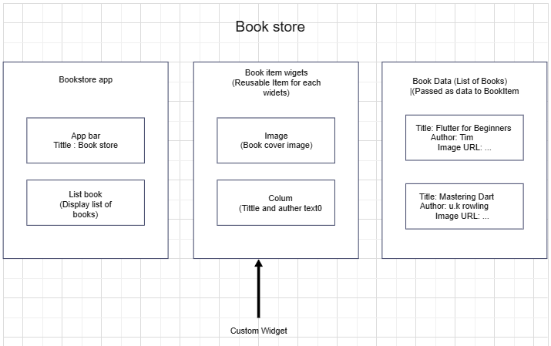

**Hierarchy diagram**

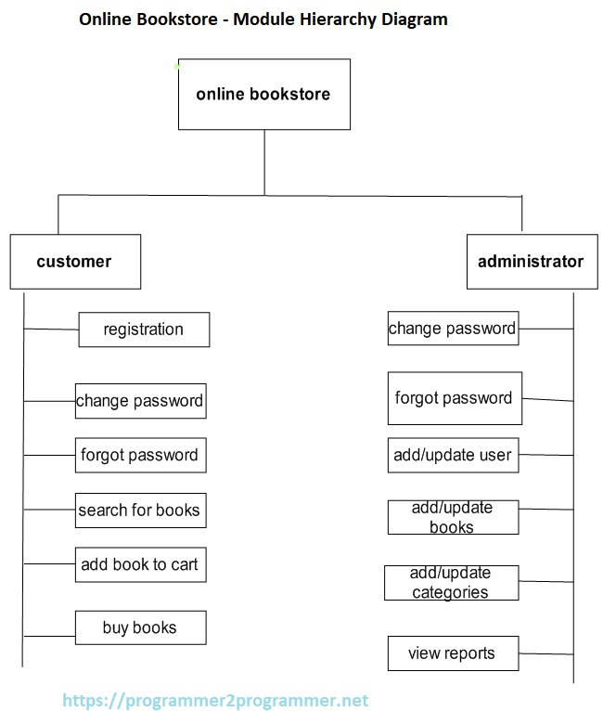

**Paste the UI here**

1. Figma prototype

https://www.figma.com/design/gPtWhbLqPVUSKLi8982oaU/Book-App?node-id=0-1&t=CG7XSnrB4lvijJGu-1

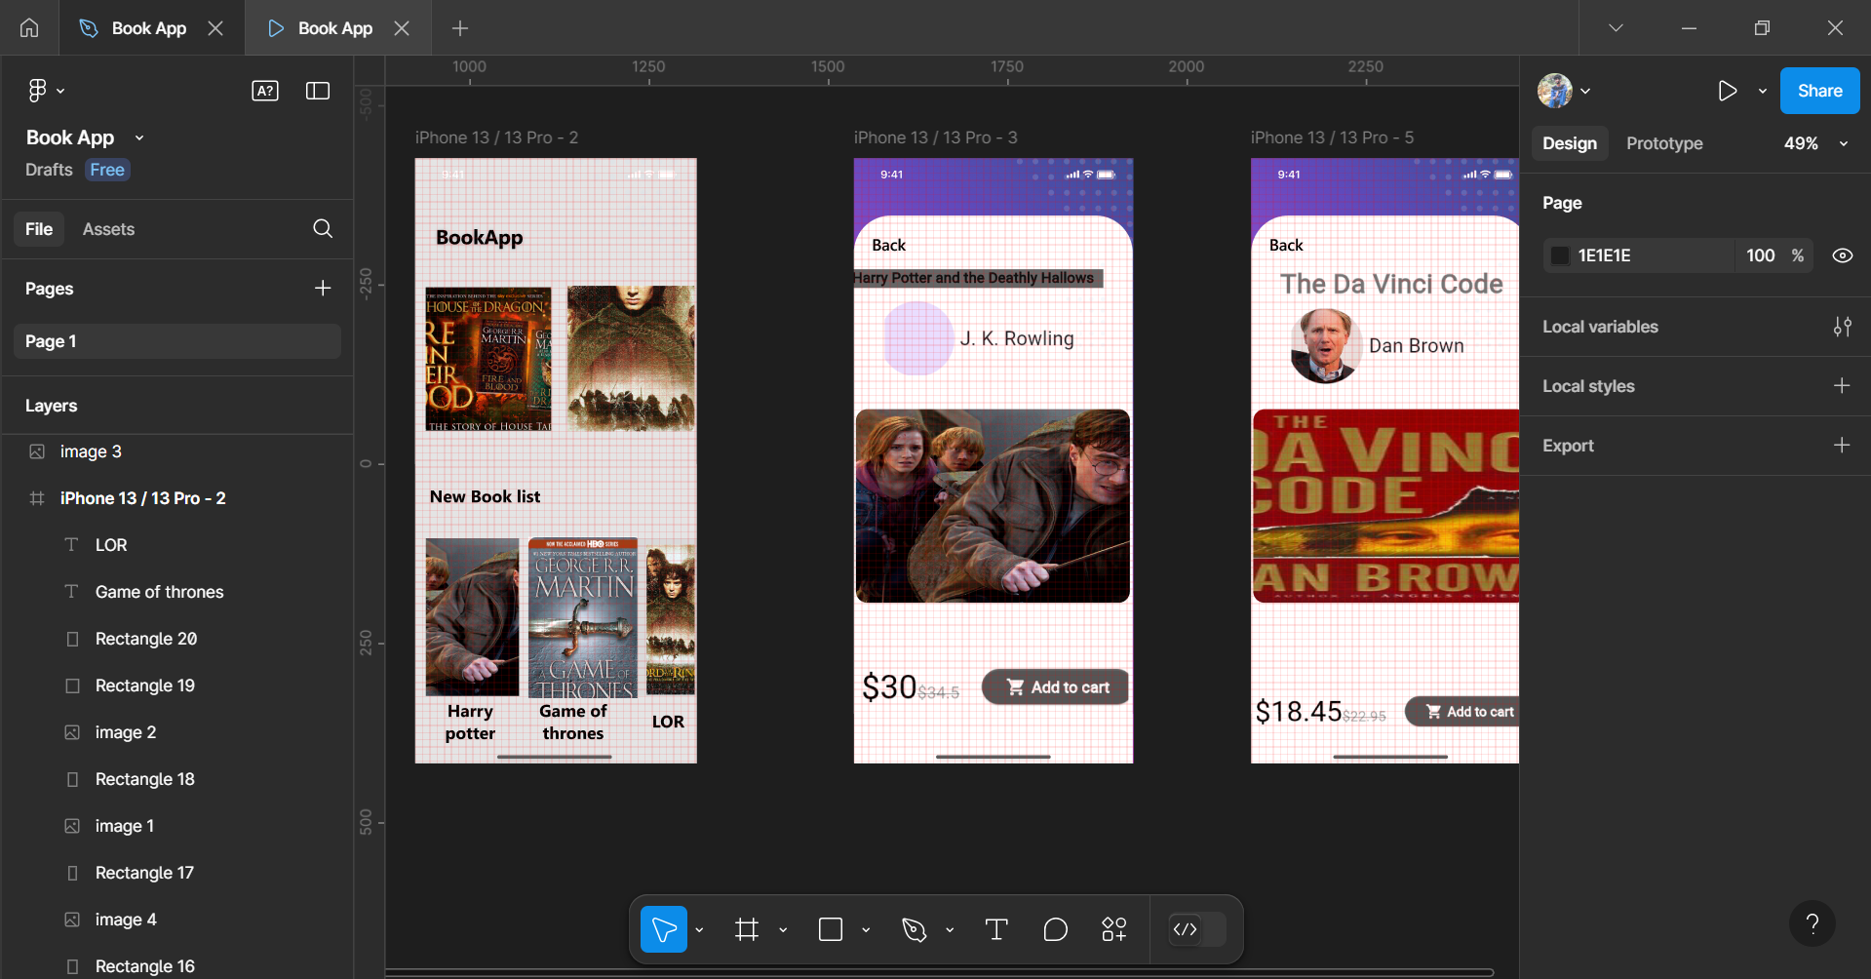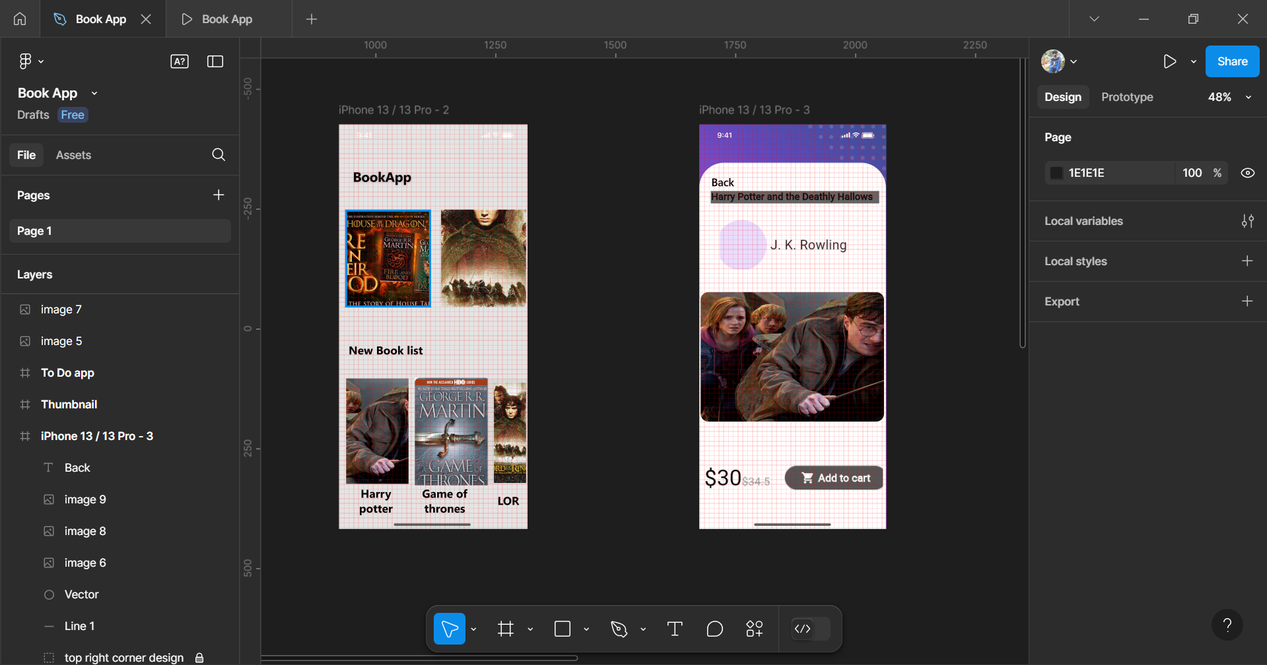

b. Final Flutter UIs

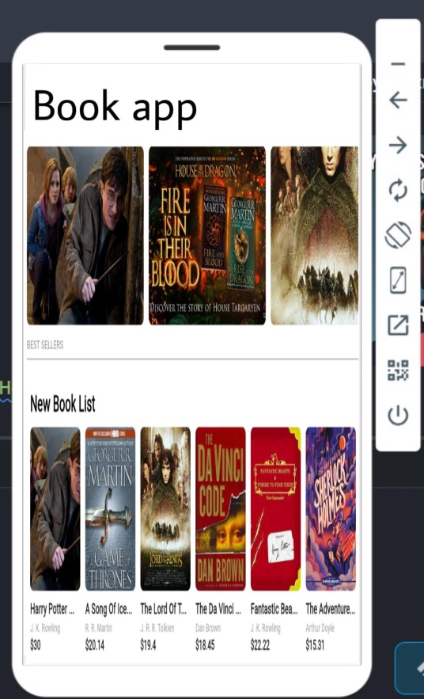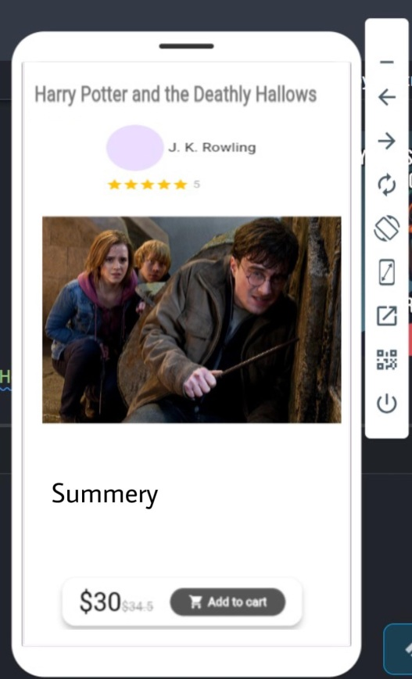 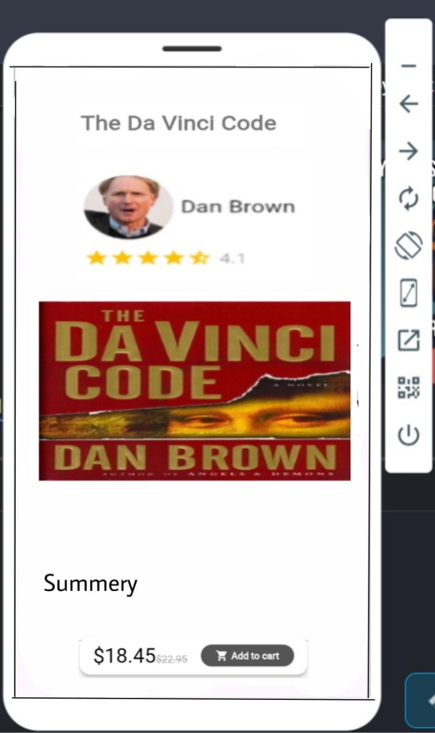

# Lessons learnt

Notes on what you learnt in doing this activity.

1. **Everything is a widget**: Even structural elements like rows, columns, and grids are widgets in Flutter. This modular approach helps to create reusable components, like BookItem, which makes your code cleaner and more maintainable.
2. **Widget Composition**: Complex layouts are built by combining simple widgets. In this example, the BookItem widget is a combination of Row, Column, Text, and Image, and the ListView.builder is used to display multiple book items.
3. **Custom Widgets**: By creating a BookItem widget, the UI becomes more flexible and reusable. If you need to modify the way a book item is displayed, you only need to modify the BookItem widget, rather than changing each occurrence individually.
4. **State Management**: Although this example doesn’t involve state management, real-world apps may need dynamic updates. You could integrate state management tools (e.g., Provider, Riverpod, etc.) to handle user interactions, data fetching, etc.
5. **Responsive Layouts**: Flutter allows for responsive layouts using widgets like Expanded, Flexible, and MediaQuery to make sure your UI adapts to different screen sizes. In this case, we used Expanded inside the Row widget to make the text take up the available space next to the image.